Furthest from labour market
- Some Innovative approaches

What are 10 innovative approaches to supporting those furthest from the labour market?

Also see: http://blogs.worldbank.org/jobs/accelerating-and-learning-innovations-youth-employment-projects

 | Country / Region
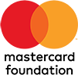  Mastercard foundation  http://www.mastercardfdn.org/ | Africa | The MasterCard Foundation works organizations to provide greater access to education, skills training and financial services for people living in poverty, primarily in Africa.  Currently working in 29 countries across Africa.  Case study : Young Africa Works  By 2030, enable 30 million young people in Africa to secure employment they see as dignified and fulfilling.  http://www.mastercardfdn.org/strategy/
Project180  https://www.project180reentry.org/ | USA | Florida-based project based inside prisons providing workforce education and financial literacy classes for inmates plus an annual reentry lecture series for the general public. Their current goal is to open a long-term, 24/7 residential program for reentering men who wish to turn their lives around.  Residential Program: 2-year clean and sober program to men returning from Florida's prison system  Financial literacy course: deliver financial literacy courses inside Florida Gulf Coast prisons and jails.  CEO workforce program: takes CEOs, hiring managers and workforce agency specialists into the prisons to teach soon-to-be-released inmates how to find, apply for, interview for and retain a position in each CEO’s industry.  https://www.project180reentry.org/programs/
Talent Match https://www.biglotteryfund.org.uk/talentmatch | UK | Supporting young people aged 18 – 24 who have been out of work, education or training for 12 months or more.  An £108 million investment to tackle youth unemployment in 21 areas of England.  Talent Match is targeting young people who are furthest from the jobs market, including those who are completely outside of the benefits, work and training system and facing severe barriers to gaining the skills they need to get into work.  Some activities are delivered through Princes Trust
https://www.thewisegroup.co.uk/ | North East, UK | Lottery funded. Talent Match North East between 18 and 24 and have been out of education, employment or training for 12 months or more.  Works with partners across North East.  Case study with ex-offender [Source]
National Citizen Service  http://www.ncsyes.co.uk/ | UK | NCS is a 3-4 week experience that helps build confidence and self belief. Live away from home, develop skills and meet amazing people.  UK-wide initiative; can help build confidence and aid 15-17 year olds gain experience, skills and confidence.  Not necessarily about jobs.
Palmersville Training  http://www.barnardos.org.uk/palmersville-training.htm | UK | Palmersville Training offer Study Programme and Apprenticeships for young people aged 16-24 with no entry requirements. It is aimed at trade-related skills.  Palmersville in Benton provides advice and advocacy on the skills needed to support, obtain and maintain a job. Focusing on confidence, resilience and self-esteem through employment, work experience and educational opportunities through trade-skills;  * Hairdressing- Level 1, Level 2, and Level 3  * Painting and decorating- level 1 and level 2  * Customer Service- Level 2 and Level 3  * Business Admin- Level 1, Level 2, Level 3 and Level 4  * Beauty Therapy- Level 1, Level 2, and Level 3  * Retail- Level 1 and Level 2  * Warehousing- Level 2  * Team Leading/Management- Level 3  * Functional Skills Maths, English and ICT  * Employability Skills  Prospectus  http://www.barnardos.org.uk/pv-Barnardos-Prospectus.pdf
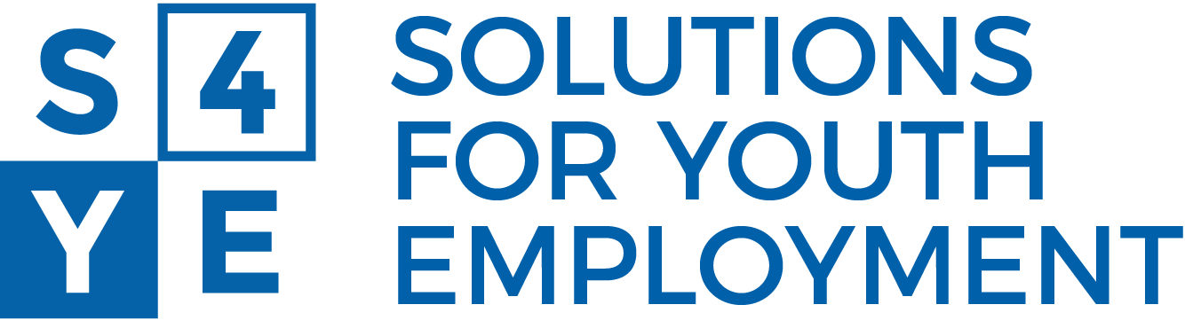  https://www.s4ye.org/impact-portfolio | Global | With sites ranging from Colombia to Cambodia and Turkey to Tanzania, the S4YE Impact Portfolio (IP) is a group of 19 diverse and high-potential youth employment projects that represent fifteen developing countries from six continents.  From report [Source]:  Microsoft and Silatech’s Ta3mal platform in Tunisia includes the use of online psychometric self-assessment tool to guide youth in career choices based on their personality, interests, and individual attributes.  In Tunisia, the FORSATI project allows youth to meet  with career counselors, who help them develop and  sign a personal action plan for their career  exploration and job search process, to be executed  over the following 6 to 12 months.  The World Bank's Kenya Youth Employment and Opportunities (KYEOP) project is experimenting with the design of a youth-friendly entrepreneurship aptitude test.  Identifies sectors: Digital/STEM, Healthcare, Energy/green jobs, Construction and logistics jobs, Hospitality and tourism jobs, Agri-business and modern agriculture jobs.

